Comparison of Bushing Seismic Test Between IEEE 693:2005 and IEC TS 61463:2016
 | IEC TS 61463:2016 | IEEE 693:2005
Scope | Um>52kV, AC and DC Bushings | Substation Buildings, Structures and Equipment (Clause 8)  Annex A and D include requirements for Bushings
Severities  /Qualification Level | AG2: ZPA=0.2g  AG3: ZPA=0.3g  AG5: ZPA=0.5g | Low: 0.1g ZPA  Moderate: 0.25g ZPA  High: 0.5g ZPA  Performance Level: Twice Moderate or High – 0.5g or 1.0g
Qualification Method | Static analysis  Dynamic analysis (RRS, Time History Dynamic)  Test (Time History, Sine-beat, other waveforms) | Analysis (Static, static Coefficient, Response Spectrum Dynamic, Time History Dynamic)  Test (Time History, Sine-beat, Static Pull)
Time history shake-table test | 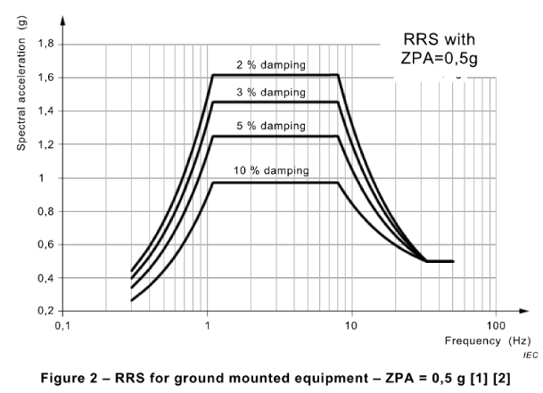  - Test on the complete apparatus/simulating support, the time-history method is recommended. Test on the bushing alone the sine-beat test method is recommended.  - External Load: 7kg for Um<=420kV, 11kg for Um>420kV;  - Vertical Acceleration: 50% of the horizontal;  - Damping: 3% and 5% damping apply for GIS bushing and Transformer bushing respectively.  - Standard Frequency Range: 0.3Hz to 33Hz;  - Duration: total duration of the time-history should be about 30s of which the strong part not less than 20s.  - Measurement: 1) acceleration at both ends of the bushing and the Centre of gravity; 2) displacement of the top of the bushing; 3) stains on critical cross-sections;  - Axes: Triaxial  - Amplification Coefficient/Superelevation Factor for Bushing: 1.5 or 2. 1.5 for GIS bushing; 1.5 and 2 for transformer bushing mounted on the transformer cover directly and turret, respectively. | 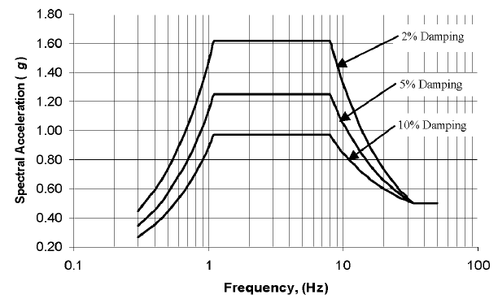  - Bushings 161 kV and above shall be qualified using a time history test.  - Mounting: the bushing(s) shall be mounted on a rigid stand during the test.  - External Load: 7kg for Um<500kV, 11kg for Um>=500kV;  - Vertical Acceleration: 80% of the horizontal;  - Damping: the theoretical response spectrum for testing shall be computed at 2% damping, at the resolution stated, and shall include the lower corner point frequency of the RRS (1.1 Hz), for comparison with the RRS;  - Duration: the input motion shall have a duration of at least 20 s of strong motion.  - Output motion: the table output TRS shall envelop the RRS within a –10%/+50% tolerance band at 12 divisions per octave resolution or higher.  - Measurement: 1) acceleration at both ends of the bushing, flange, the Centre of gravity and the shake-table; 2) displacement of the top of the bushing; 3) stains at the flange metal end fitting and attachment bolts.  - Axes: Triaxial  - Amplification Coefficient: 2. The bushing shall be tested to twice the input level required at the top of the transformer.
Acceptance criteria | After the vibration test the bushing shall pass a routine test acc. to IEC 60137. (9.1.1)  - No crack, leakage, permanent deflection or relative movement of parts is permitted.  - its components made by composite material are not stressed over 1,5 times their maximum mechanical load (MML), which corresponds normally to the elasticity limit of the material, in accordance with IEC 61462, and NOTE Different acceptance criteria can be agreed between purchaser and manufacturer, in accordance to other Standards or Specifications.  - metallic parts are not stressed above the yielding point by the combined stresses. Assembly fittings, specially designed for seismic purpose (e.g. to reduce the natural frequency or increase the damping) may however use friction and ductility in a controlled way. | After shake-table testing of bushings, they shall be subjected to and pass all routine tests as specified in the latest revision of IEEE Std C57.19.00. (D.5.2).  The general criteria are specified in sections D.5.1 and A.2.6 of IEEE-693-2005.  - The permanent deformation of the composite polymer bushing must be less than 5% of peak deflection.  - Gaskets shall not suffer from leakage, obvious permanent movement of the gasket, or permanent movement relative to the gasket.  - Overall structural integrity of the equipment and its mounting shall be maintained. Metal parts may deform, but not enough to cause loss of function.  - Components shall not shake loose or break off their mountings enough to cause loss of function.  - Relative deflections from the pull tests after seismic testing shall not increase by over 15% from the original pull tests.  - Wiring damage must not occur enough to cause loss of function.  - Mounting bolts shall not fail to cause loss of function or safety hazard and shall be retorqued after each test.

